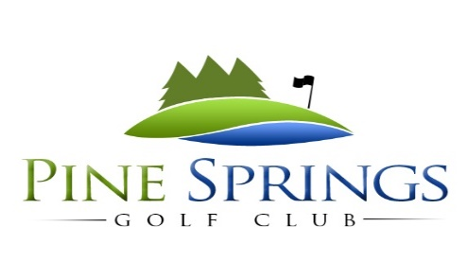

6th Annual Toy Drive Golf Tournament
Saturday, December 10th, 2022
Benefitting Smith County Families in Need
2-Person Scramble / 10:00AM Shotgun Start / $200 Per TeamSponsorships Available
Title Sponsor: $5000 - Includes 2 team entry fees, a hole flag, a hole sign, social media and website recognition, event & scoreboard sponsorship with your logo on the golf balls in giveaway bag.
Gold Corporate Sponsor: $1000 - includes team entry fee, hole flag, hole sign, social media and website recognition, and item with company logo in giveaway bag.
Silver Corporate Sponsor: $500 - includes team entry fee, hole flag, hole sign, social media and website recognition.
Driving Range or Putting Green Sponsor: $1000 - Includes entry fees for one team, hole sign, and a sign on the driving range or putting green, social media, and website recognition.
Hole Flag Sponsor: $300 Includes your information on a hole flag which will be used during the event.
Long Drive & Closest to the Pin Sponsors: $200 for each contest. (6 Available - $800 for all) Includes a hole sign, your information on a contest sign and recognition when the award is given.
Hole Sign Sponsor: $100 for each hole. Includes your information on a hole sign.
--------------------------------------------------------------------------------------------------------------------------------------
Thank you for supporting the families of Smith County and helping to create a memorable Christmas!
Sponsorships can be mailed to: Attn: Pine Springs Golf Club
P.O. Box 501 Chandler, Texas 75758
Company: ___________________________________________________________Contact Person: ______________________________
Contact email: ______________________________________________________ Contact phone: _______________________________
Sponsorship chosen: _______________________________________________Sponsorship paid by: _________________________
Please email logo or information to be used on signage to: cotton@pinespringsgolf.com
Raffle Prize Contributor – item or service: ________________________________________________________________________
Questions: please call Cotton Davis at 469-396-8064 or the golf course at 903 526-4653

